Supplementary Information
Deciphering symbiotic interactions of ‘Candidatus Aenigmarchaeota’ with inferred horizontal gene transfers and co-occurrence networks

Yu-Xian Li^{1,†}, Yang-Zhi Rao^{1,†}, Yan-Ling Qi¹, Yan-Ni Qu¹, Ya-Ting Chen¹, Jian-Yu Jiao¹, Wen-Sheng Shu², Hongchen Jiang³, Brian P. Hedlund^{4,5}, Zheng-Shuang Hua^{1, 6*}, Wen-Jun Li^{1,7*}

¹State Key Laboratory of Biocontrol, Guangdong Provincial Key Laboratory of Plant Resources and Southern Marine Science and Engineering Guangdong Laboratory (Zhuhai), School of Life Sciences, Sun Yat-Sen University, Guangzhou, 510275, PR China
²School of Life Sciences, South China Normal University, Guangzhou 510631, PR China.
³State Key Laboratory of Biogeology and Environmental Geology, China University of Geosciences, Wuhan, 430074, PR China.
⁴School of Life Sciences, University of Nevada Las Vegas, Las Vegas, NV 89154, USA.
⁵Nevada Institute of Personalized Medicine, University of Nevada Las Vegas, Las Vegas, NV 89154, USA.
⁶Department of Biological Sciences, Dartmouth College, Hanover, NH 03755, USA.
⁷CAS Key Laboratory of Biogeography and Bioresource in Arid Land, Xinjiang Institute of Ecology and Geography, Urumqi, 830011, PR China

†These authors contributed equally to this work.
* Correspondence authors: W.J.L., liwenjun3@mail.sysu.edu.cn; Z.S.H. hzhengsh@foxmail.com.

Supplementary Notes
Supplementary Note 1: Description of sample sites
DiReTiYanQu (DRTY) is an artificial concrete hot spring landscape experiencing area. DRTY-6 and DRTY-7 are two medium size pools that have mixture of spall, sand and soil on the bottom. GuMingQuan (GMQ) is a pool with a hot spring fall above and with length, width and depth around 98, 79, and 9.5 cm respectively. Leaf litter and other debris on the bottom could be seen clearly. The sampling site locates at the upstream of GMQ pool, which was named GMQS. QiaoQuan (QQ) is a hot spring stream flowing out from a soil slope with a rust-color trace. This spring is surrounded by bush and grass. JinZe-2 (JZ-2) pool is an artificial concrete cubic hot spring water reservoir with a celling covering on the top in JinZe Hot Spring Resort. JZ-2 pool contains turbid water and some sink on the bottom of the pool.

Supplementary Figures
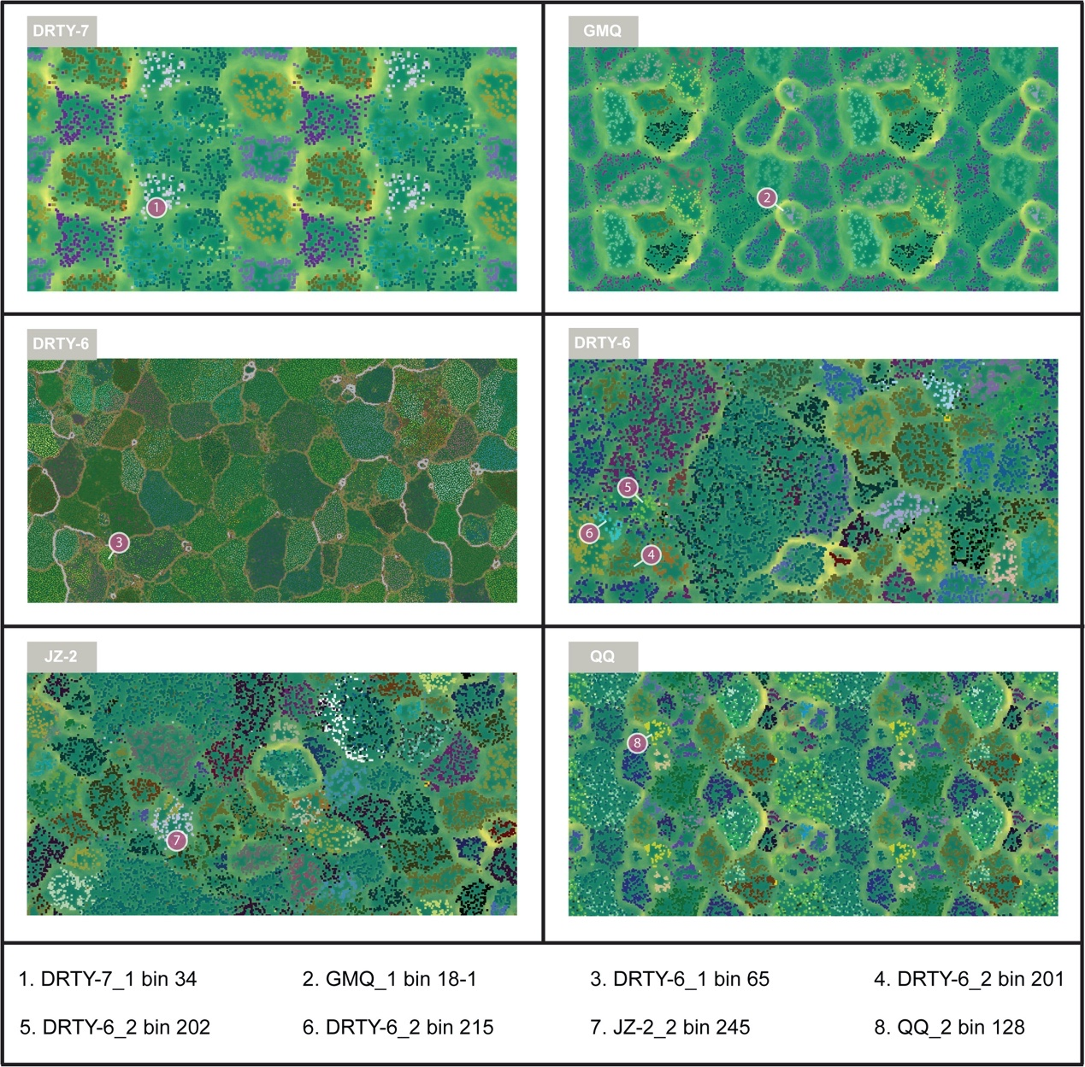
Supplementary Figure 1. Visualization of metagenomic-assembled genomes (MAGs) in this study. The MAGs in this study were visualized by ESOM (Emergent Self-Organizing map)¹. Sampling site information for reconstructed MAGs was shown in Supplementary Table 1 and Table 1.

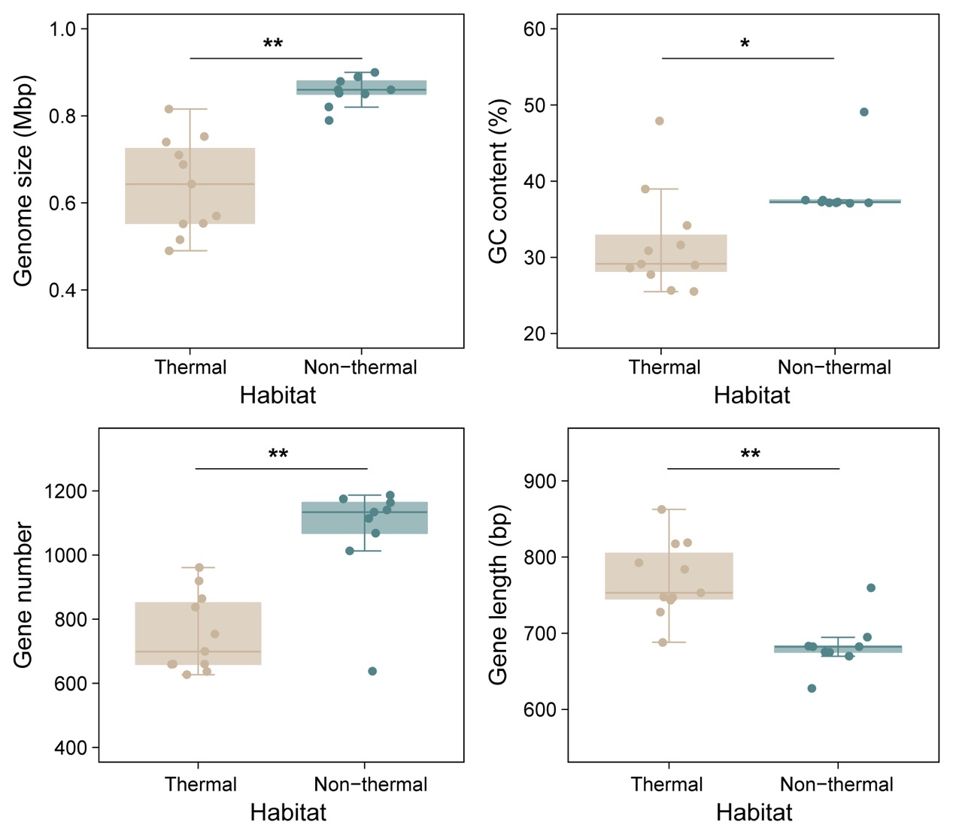
Supplementary Figure 2. Boxplot of genome size, GC content, gene number and gene length of genomes from thermal environment and non-thermal environment. Genome size, GC content, gene number and gene length of genomes from thermal environment and non-thermal environment were visualized with ggplot2 package (v3.1.0) in RStudio². The Mann-Whitney U test³ was conducted between the data of two habitats. “*” represent that P value of the Wilcoxon test was below 0.05, and “**” represent that P value of the Wilcoxon test was below 0.01.

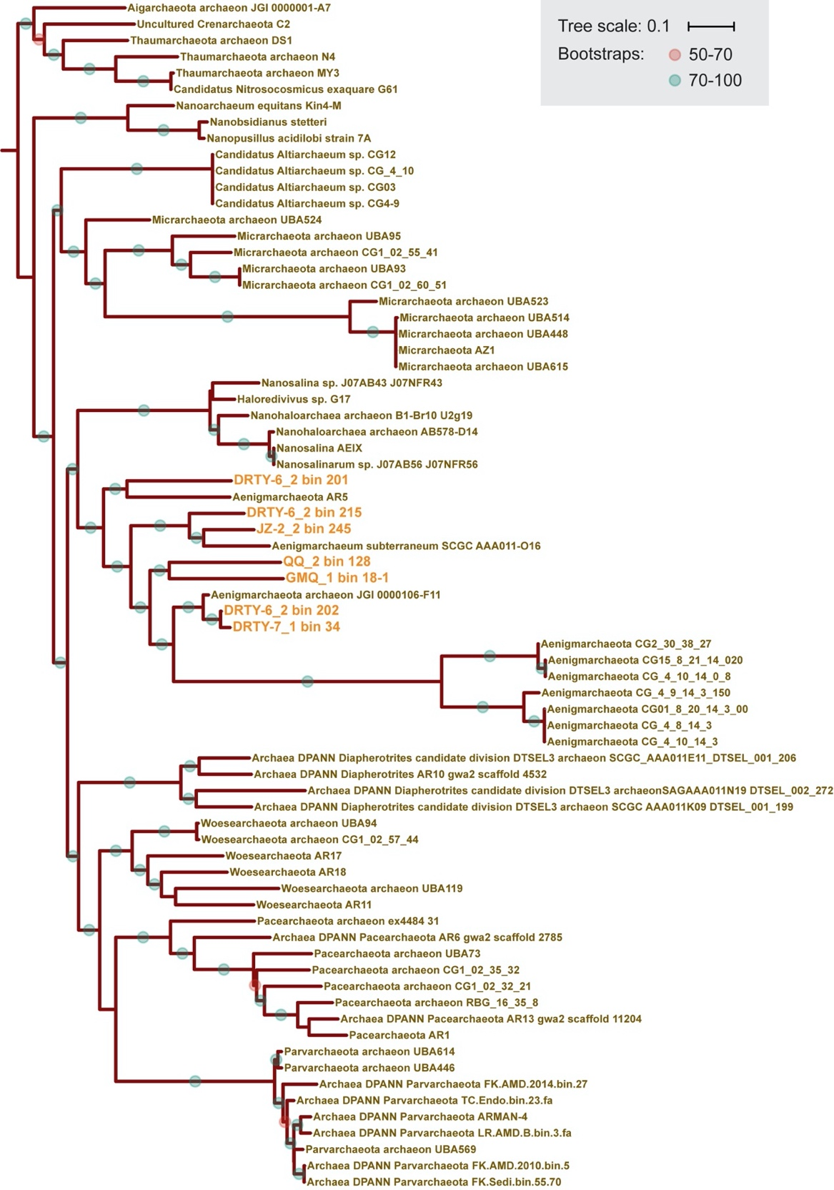
Supplementary Figure 3. The maximum-likelihood phylogenetic trees of 16S rRNA gene. 16S rRNA genes of genomes affiliated to DPANN and TACK superphylum were used to construct the maximum-likelihood phylogenetic tree, and 16S rRNA genes of MAGs in this study were represented in orange. Bootstraps value ≥ 50 were displayed, orange dots represented bootstrap value from 50-70, green dots represented bootstrap value in ≥ 70.

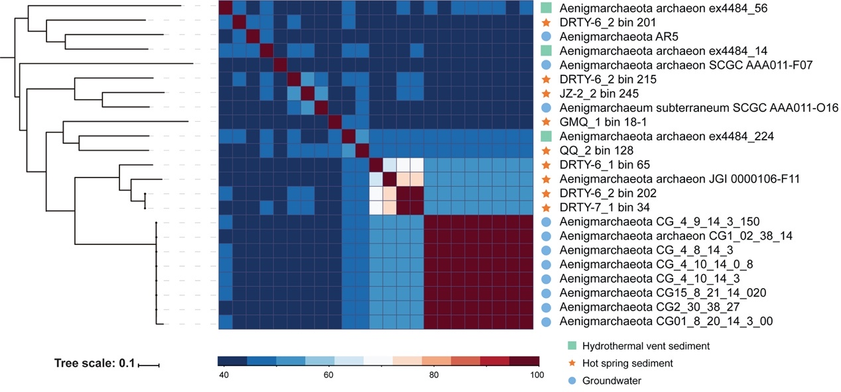
Supplementary Figure 4. Heatmap based on average amino acids identity (AAI) of pairwise ‘Ca. Aenigmarchaeota’ genomes hierarchical clustered with 16 ribosomal proteins concatenated phylogenetic tree. AAI was calculated as the mean similarity of all orthologous genes identified based on reciprocal best BLAST hits (E-value < 1e-5). The phylogenetic tree on the left were the clade of ‘Ca. Aenigmarchaeota’ from 16 ribosomal proteins concatenated phylogenetic tree. Habitats corresponding with each genome were represented by different symbols: marine sediment in squares, hot spring sediment in star-shapes, and groundwater in solid circles.

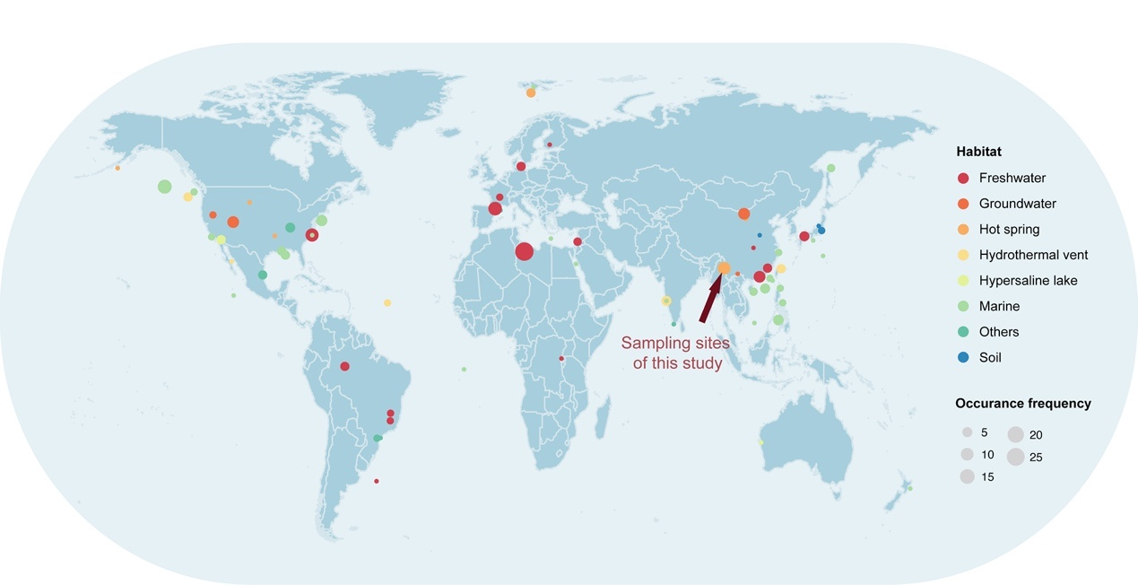
Supplementary Figure 5. Global distribution of the 16S rRNA genes of ‘Ca. Aenigmarchaeota’. We recovered in total 17 16S rRNA genes sequences from all currently available ‘Ca. Aenigmarchaeota’ genomes, including seven from this study and ten from other studies. These sequences were used as input to search against the NCBI-nt (https://www.ncbi.nlm.nih.gov/) database via BLASTn program with the default parameters. The hits for each individual BLAST search that have coverage > 95% and identity > 85% were kept and corresponding sequences were downloaded. Then, a maximum likelihood phylogenetic tree was constructed using RAxML (v7.2.7)⁴, sequences located outside of ‘Ca. Aenigmarchaeota’ phylum were removed. Finally, we retrieved 234 16S rRNA sequences from NCBI database and collected associated data. The 16S rRNA of eight different ecosystems were plotted with different color dots on the global map visualized with R using ggplot2 package (v3.1.0) in RStudio². Occurrence frequencies indicate the number of 16S rRNA genes founded in corresponding locations.

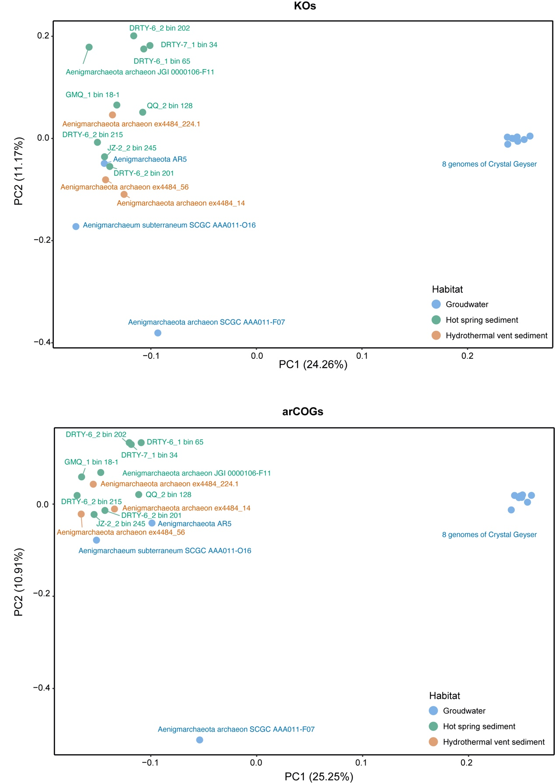
Supplementary Figure 6. Principal component analysis (PCA) plots with KEGG Orthologies (KOs) and archaeal clusters of orthologous groups (arCOGs) of all 23 ‘Ca. Aenigmarchaeota’ genomes. Analyses were conducted using vegan package (v2.5-4) and visualized with ggplot2 package (v3.1.0) in RStudio^{2,5}.

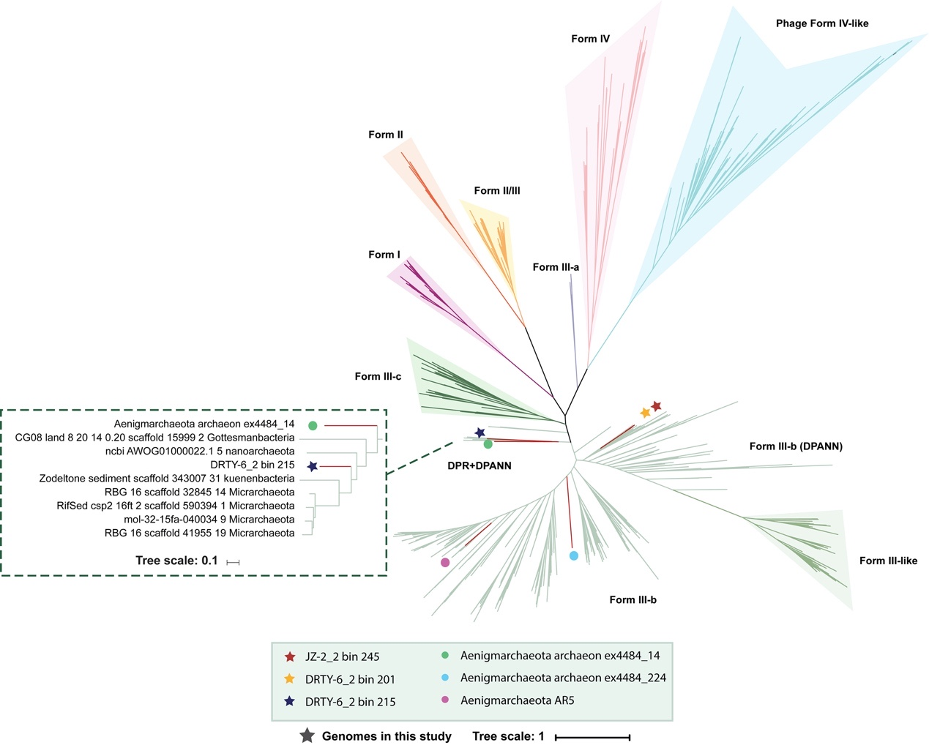
Supplementary Figure 7. Unrooted maximum-likelihood tree of Rubisco large subunit. Unrooted maximum likelihood phylogenetic tree generated by RAxML⁴ with detailed parameters as: -f a -n boot -m PROTGAMMAIJTT -c 4 -e 0.001 -p 13452 -x 1165 -# 1000. Rubisco genes of genomes in this study were represented in star-shapes in different colors. Reference sequences of Rubisco large subunit were obtained from previous study⁶. All sequences were aligned using MAFFT⁷. Poorly aligned regions were removed using TrimAl⁸.
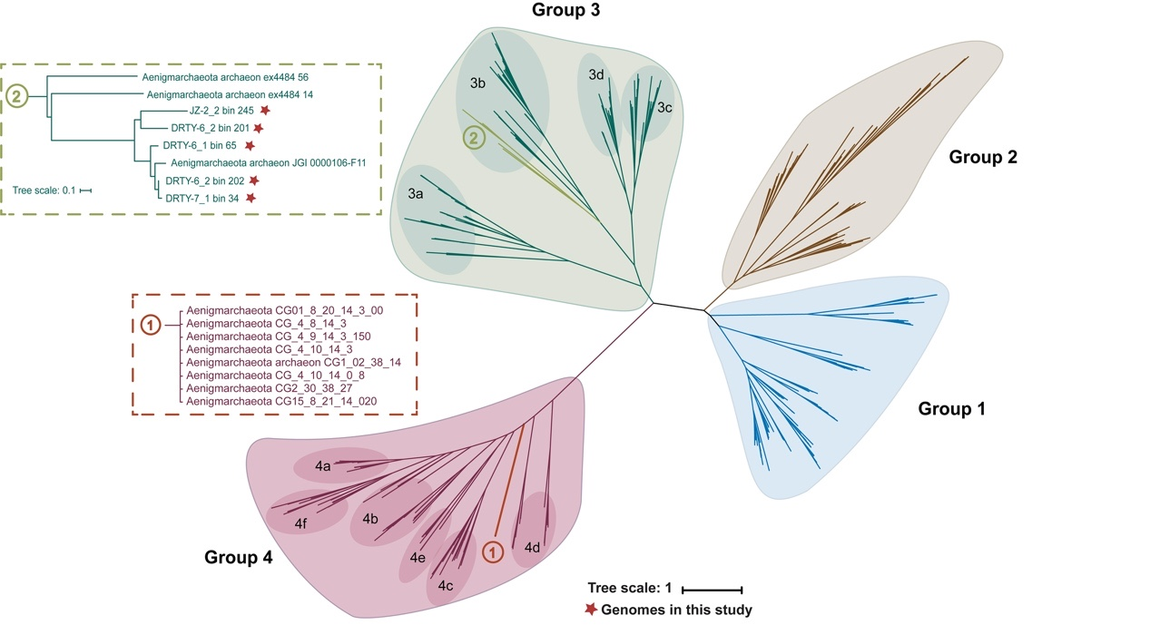
Supplementary Figure 8. Unrooted maximum-likelihood tree of hydrogenases. Hydrogenases gene of genomes in this study were represented in red star-shapes. All reference sequences of hydrogenases were selected from previous study⁹ and listed in table S6. Alignments were generated using MUSCLE¹⁰ and divergent regions were filtered using TrimAl⁸. The same model and detailed parameters as Rubisco large subunit phylogeny were used to construct the hydrogenases tree

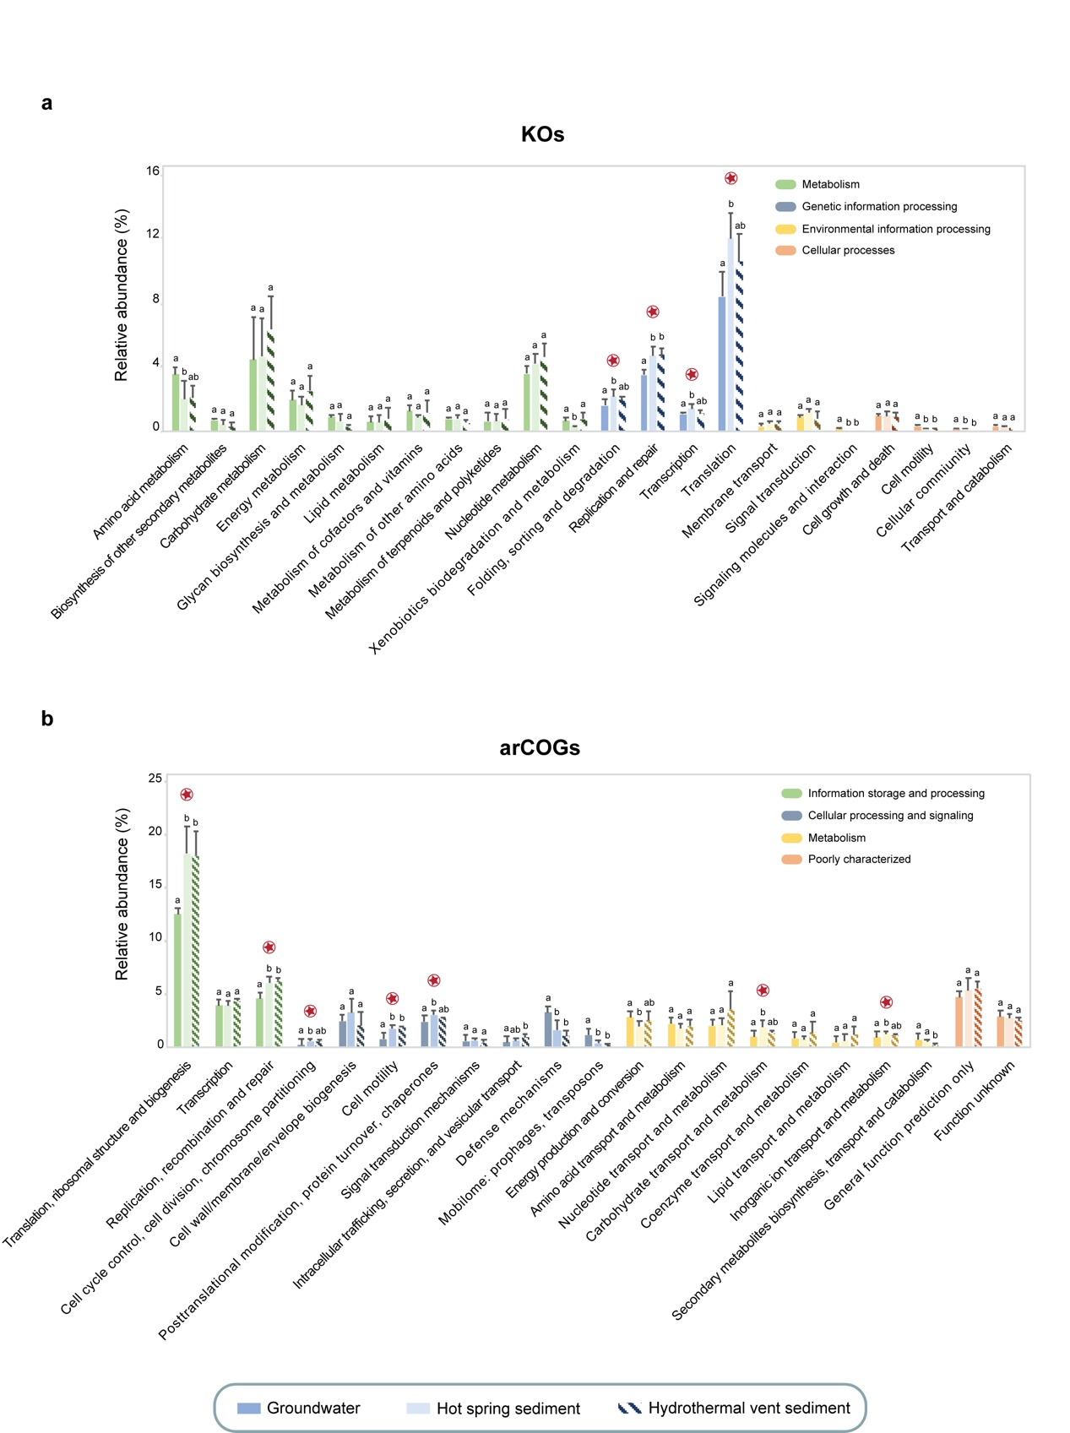
Supplementary Figure 9. Metabolic category of genomes obtained from three habitats. Based on annotation results of (a) KOs and (b) arCOGs, relative abundance of each metabolic category of three habitats was represented by bars with different filling. Because of the low completeness of three genomes obtained by single cell, we removed them to avoid bias. A higher-level metabolic category was showed by different color bars. The Standard Deviation (SD) and dissimilarity (tested using multiple comparisons) of three habitats were marked on the top of the bars¹¹. For dissimilarity of habitats, bars with different letters (such as “a” and “b”) mean the significant difference among habitats, and bars with the same letter (such as “a” and “ab”) mean no significant dissimilarity. And relative abundance of categories, which were significant higher in hot spring sediment, were marked by star-shape symbols.
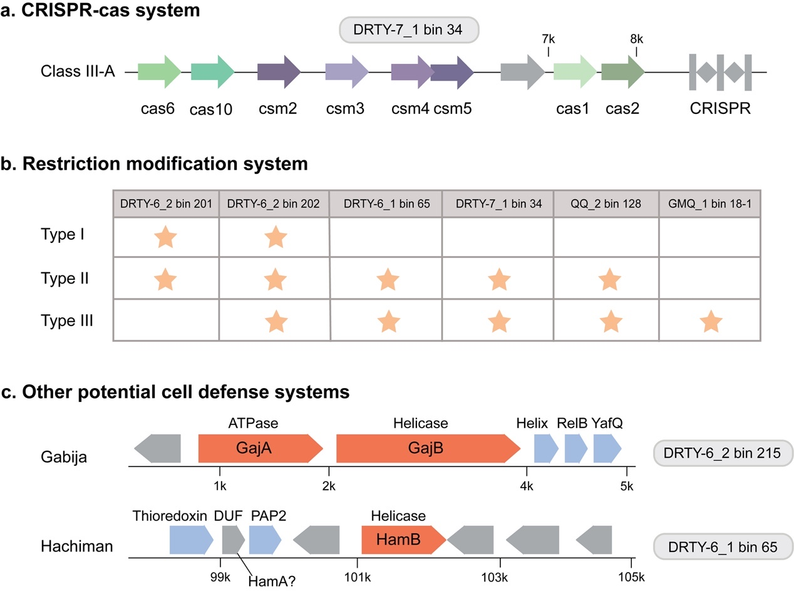
Supplementary Figure 10. Cell defense systems in ‘Ca. Aenigmarchaeota’ in hot spring. (a) CRISPR-Cas system, (b) restriction modification (RM) system and (c) other potential cell defense systems that we found in the eight MAGs. The grey arrays represented sequences that annotated as “hypothetical protein” in the gene clusters.

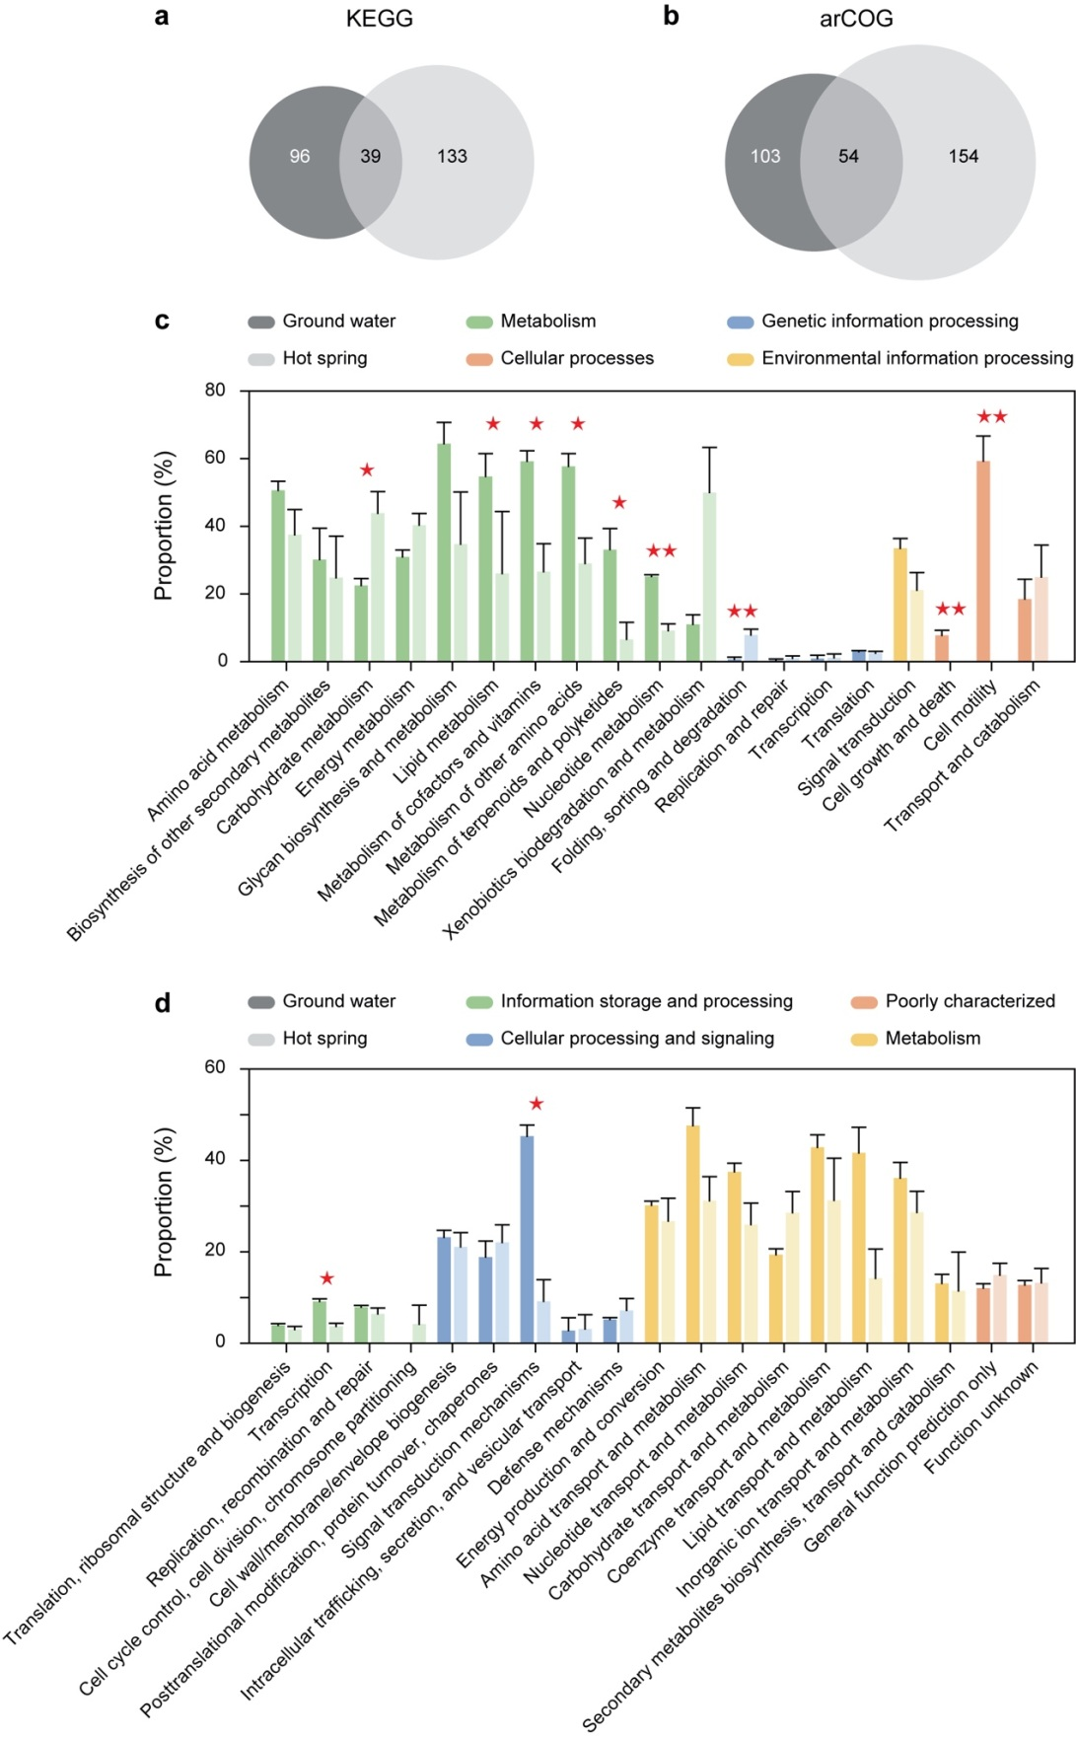
Supplementary Figure 11. Detected HGTs among genomes from this study (eight MAGs) and groundwater (nine MAGs). Venn diagrams show specific and shared KOs (a) and arCOGs (b) identified as HGTs between genomes from hot spring and groundwater. The comparisons between identified HGTs at KEGG level2 (c) and arCOG categories (d) are shown. Red stars denote significant differences between specific categories in the two types of habitats. The y-axis indicates the proportion of identified HGTs to the genes in the specific category in the corresponding genome.
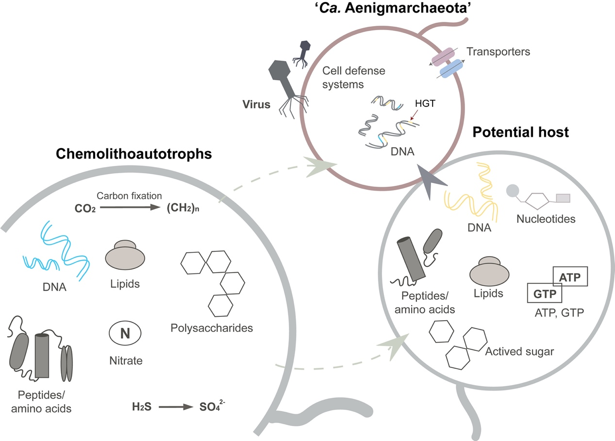
Supplementary Figure 12. The proposed co-evolution model of ‘Ca. Aenigmarcheaota’ with community members. Figure shows the participants and their roles in the co-evolution in the hot spring communities. Those chemolithoautotrophs work as primary producers who can assimilate carbon, nitrogen, sulfur and phosphorus into organic compounds. Potential hosts of ‘Ca. Aenigmarchaeota’ stay in proximity in order to utilize the substrates supplied by primary producers to sustain cell growth. The byproducts produced by potential hosts were subsequently delivered and utilized by the symbionts, which in the meanwhile could provide protection against virus infection in return.

Supplementary Tables
Supplementary Table 1. Physical and chemical characteristics of hot spring sampling sites.
Date | Samples | Latitude | Longitude | Temp | pH | TOC | DOC | Cl⁻ | NH₄⁺ | SO₄²⁻ | NO₃⁻ | Na⁺ | NO₂⁻ | K⁺ | Mg²⁺ | Ca²⁺
2016.01 | DRTY-6_1 | 24˚57'14'' | 98˚26'18'' | 50 | 6.1 | 9.8 | 577 | 6.8 | 9.9 | 825 | 5.2 | 14 | 11 | 43 | 46 | 267
2016.01 | DRTY-7_1 | 24˚57'14'' | 98˚26'18'' | 56 | 6.0 | 11 | 26 | 5.9 | - | 2050 | 3.5 | 9.7 | 8.2 | 15 | 133 | 522
2016.01 | GMQ_1 | 24˚57'3'' | 98˚26'10'' | 89 | 9.0 | 0.03 | 39 | 655 | 6.6 | 41 | 3.9 | 772 | 25 | 71 | 0.50 | -
2017.05 | DRTY-6_2 | 24˚57'14'' | 98˚26'18'' | 60 | 6.0 | - | - | 4.8 | 4.2 | 1037 | 2.6 | 12 | - | 17 | 62 | 248
2017.05 | QQ_2 | 24°57' | 98°26'24" | 77 | 7.2 | - | - | 164 | - | 46 | 1.2 | 258 | 2.3 | 48 | 8.3 | 24
2017.05 | JZ-2_2 | 25˚26'28'' | 98˚27'36'' | 63 | 7.6 | - | - | 136 | - | 27 | 0.3 | 408 | 16 | 38 | 3.8 | 19
All values are in mg L⁻¹, except pH (in standard units), Temperature (ºC), TOC (in mg g⁻¹).
Abbreviations: TOC, total organic carbon; DOC, dissolved organic carbon.

Supplementary Table 2. The occurrences of 54 archaeal conserved single copy genes in genomes of ‘Ca. Aenigmarchaeota’.
Single copy gene | JZ-2_2 bin 245 | DRTY-6_1 bin 65 | DRTY-7_1 bin 34 | GMQ_1 bin 18-1 | DRTY-6_2 bin 201 | DRTY-6_2 bin 202 | DRTY-6_2 bin 215 | QQ_2 bin 128
Glutamyl- and glutaminyl-tRNA synthetases | 1 | 1 | 1 | 1 | 1 | 1 | 1 | 1
Alanyl-tRNA synthetase | 1 | 2 | 1 | 1 | 1 | 1 | 1 | 1
Phenylalanyl-tRNA synthetase alpha subunit | 1 | 1 | 1 | 1 | 1 | 1 | 1 | 1
Aspartyl-tRNA synthetase | 2 | 1 | 1 | 2 | 2 | 1 | 2 | 1
Arginyl-tRNA synthetase | 1 | 1 | 1 | 1 | 1 | 1 | 1 | 1
Methionine aminopeptidase | 1 | 0 | 1 | 1 | 1 | 1 | 1 | 1
Ribosomal protein S12 | 1 | 1 | 1 | 1 | 0 | 1 | 1 | 1
Ribosomal protein S7 | 1 | 1 | 1 | 1 | 1 | 1 | 1 | 1
Ribosomal protein S10 | 1 | 1 | 1 | 1 | 1 | 1 | 1 | 1
Ribosomal protein S2 | 1 | 1 | 1 | 1 | 1 | 1 | 1 | 1
Isoleucyl-tRNA synthetase | 1 | 1 | 1 | 1 | 1 | 1 | 1 | 1
Phenylalanyl-tRNA synthetase beta subunit | 1 | 1 | 1 | 1 | 2 | 1 | 1 | 1
Ribosomal protein L11 | 1 | 1 | 1 | 1 | 1 | 1 | 1 | 0
Ribosomal protein L1 | 1 | 1 | 1 | 1 | 1 | 1 | 1 | 1
DNA-directed RNA polymerase subunit B | 1 | 1 | 1 | 1 | 1 | 1 | 1 | 2
Ribosomal protein L3 | 1 | 1 | 1 | 1 | 1 | 1 | 1 | 1
Ribosomal protein L4 | 1 | 1 | 1 | 1 | 1 | 1 | 1 | 1
Ribosomal protein L2 | 1 | 1 | 1 | 1 | 1 | 1 | 1 | 1
Ribosomal protein L22 | 1 | 0 | 1 | 1 | 0 | 1 | 0 | 0
Ribosomal protein S3 | 1 | 1 | 1 | 1 | 1 | 1 | 1 | 1
Ribosomal protein L14 | 1 | 1 | 1 | 1 | 1 | 1 | 1 | 1
Ribosomal protein L5 | 1 | 1 | 1 | 1 | 1 | 1 | 1 | 1
Ribosomal protein S8 | 1 | 1 | 1 | 1 | 1 | 1 | 1 | 1
Ribosomal protein L6P/L9E | 1 | 1 | 1 | 1 | 1 | 1 | 1 | 1
Ribosomal protein S5 | 1 | 1 | 1 | 1 | 1 | 1 | 1 | 1
Ribosomal protein S13 | 1 | 1 | 1 | 1 | 1 | 1 | 1 | 1
Ribosomal protein S11 | 1 | 1 | 1 | 1 | 1 | 1 | 1 | 1
Ribosomal protein L13 | 1 | 1 | 1 | 0 | 1 | 1 | 1 | 1
Ribosomal protein S9 | 1 | 1 | 1 | 0 | 1 | 1 | 1 | 1
Histidyl-tRNA synthetase | 0 | 1 | 1 | 1 | 1 | 0 | 1 | 1
Methionyl-tRNA synthetase | 2 | 2 | 2 | 2 | 2 | 2 | 1 | 2
Tyrosyl-tRNA synthetase | 1 | 0 | 1 | 1 | 0 | 1 | 1 | 0
Ribonuclease HII | 0 | 1 | 1 | 1 | 1 | 1 | 1 | 1
Seryl-tRNA synthetase | 1 | 1 | 1 | 1 | 1 | 2 | 1 | 1
Tryptophanyl-tRNA synthetase | 1 | 1 | 1 | 1 | 1 | 2 | 1 | 1
Ribosomal protein S15P/S13E | 1 | 1 | 1 | 1 | 1 | 1 | 1 | 1
Ribosomal protein S19 | 1 | 1 | 1 | 1 | 1 | 1 | 1 | 1
Ribosomal protein S17 | 1 | 1 | 1 | 1 | 1 | 1 | 1 | 1
Ribosomal protein L16/L10E | 1 | 1 | 1 | 1 | 1 | 1 | 1 | 1
Ribosomal protein L24 | 1 | 1 | 1 | 1 | 1 | 1 | 1 | 1
Ribosomal protein L15 | 1 | 1 | 1 | 1 | 0 | 1 | 1 | 1
Preprotein translocase subunit SecY | 1 | 1 | 1 | 1 | 1 | 1 | 1 | 1
Cysteinyl-tRNA synthetase | 1 | 1 | 1 | 1 | 1 | 1 | 2 | 1
Transcription antiterminator | 1 | 1 | 1 | 1 | 1 | 1 | 1 | 1
Ribosomal protein L18 | 1 | 1 | 1 | 1 | 1 | 1 | 1 | 1
Glycyl-tRNA synthetase | 1 | 1 | 1 | 1 | 1 | 0 | 1 | 1
Threonyl-tRNA synthetase | 1 | 1 | 1 | 2 | 1 | 1 | 1 | 1
Prolyl-tRNA synthetase | 2 | 1 | 1 | 1 | 1 | 3 | 1 | 1
Chaperonin GroEL (HSP60 family) | 1 | 1 | 1 | 1 | 1 | 1 | 1 | 1
RecA/RadA recombinase | 2 | 1 | 1 | 1 | 2 | 1 | 2 | 1
Leucyl-tRNA synthetase | 1 | 1 | 1 | 1 | 1 | 1 | 1 | 1
Ribosomal protein S4 | 1 | 1 | 1 | 1 | 1 | 1 | 1 | 1
Valyl-tRNA synthetase | 1 | 1 | 1 | 1 | 1 | 2 | 1 | 1
Lysyl-tRNA synthetase | 1 | 0 | 0 | 0 | 0 | 0 | 0 | 1
Occurrence | 52 | 50 | 53 | 51 | 49 | 51 | 52 | 51
Completeness (%) | 96.3 | 92.6 | 98.1 | 94.4 | 90.7 | 94.4 | 96.3 | 94.4

Supplementary Table 3. Genomic summary of available draft or complete genomes of ‘Ca. Aenigmarchaeota’ from public databases.
Organism name | Taxon ID | Genome size (Mbp) | GC (%) | Compl.† | Contamin.‡ | Hetero.‡ | Unculture type | Source | Lat. | Long. | Description
Aenigmarchaeota archaeon JGI 0000106-F11 | 2264867062 | 0.36 | 37.5 | 48.1 | 0.38 | 50 | Single cell | IMG | 44.35 | -103.76 | Sediment,Thermal springs,Great Boiling Spring (GBS), Nevada
Aenigmarchaeota archaeon SCGC AAA011-F07 | 2264867064 | 0.25 | 53.5 | 33.3 | 0.00 | 0 | Single cell | IMG | 40.66 | -119.37 | Freshwater, Groundwater, Homestake Mine (HSM), South Dakota
Aenigmarchaeum subterraneum SCGC AAA011-O16 | 2264867065 | 0.43 | 38.6 | 44.4 | 0.47 | 100 | Single cell | IMG | 40.66 | -119.37 | Freshwater, Groundwater, Homestake Mine (HSM), South Dakota
Aenigmarchaeota AR5 | - | 0.85 | 49.1 | 87.0 | 0.00 | 0 | MAG | ggK | 39.53 | 107.77 | Aquifer adjacent to the Colorado River, near Rifle, CO, USA
Aenigmarchaeota archaeon CG1_02_38_14 | MNUF00000000 | 0.88 | 37.5 | 90.7 | 0.00 | 0 | MAG | NCBI | 38.56 | -110.80 | Groundwater, Crystal Geyser system in Utah, USA
Aenigmarchaeota archaeon ex4484_56 | NJDQ00000000 | 0.57 | 29.0 | 79.6 | 8.72 | 0 | MAG | NCBI | 27.04 | 111.25 | marine sediment, Guaymas Basin, Gulf of California, USA
Aenigmarchaeota archaeon ex4484_224 | NJEA00000000 | 0.49 | 27.8 | 88.9 | 0.47 | 100 | MAG | NCBI | 27.04 | 111.25 | marine sediment, Guaymas Basin, Gulf of California, USA
Aenigmarchaeota archaeon ex4484_14 | NJEI00000000 | 0.74 | 39.0 | 83.3 | 7.48 | 0 | MAG | NCBI | 27.04 | 111.25 | marine sediment, Guaymas Basin, Gulf of California, USA
Aenigmarchaeota CG01_8_20_14_3_00 | - | 0.86 | 37.3 | 90.7 | 3.97 | 0 | MAG | ggK | - | - | Groundwater, Crystal Geyser system in Utah, USA
Aenigmarchaeota CG15_8_21_14_020 | - | 0.85 | 37.1 | 90.7 | 0.00 | 0 | MAG | ggK | - | - | Groundwater, Crystal Geyser system in Utah, USA
Aenigmarchaeota CG_4_10_14_0_8 | - | 0.86 | 37.2 | 88.9 | 0.00 | 0 | MAG | ggK | - | - | Groundwater, Crystal Geyser system in Utah, USA
Aenigmarchaeota CG_4_10_14_3 | - | 0.90 | 37.3 | 90.7 | 0.00 | 0 | MAG | ggK | - | - | Groundwater, Crystal Geyser system in Utah, USA
Aenigmarchaeota CG_4_8_14_3 | - | 0.82 | 37.2 | 88.9 | 0.00 | 0 | MAG | ggK | - | - | Groundwater, Crystal Geyser system in Utah, USA
Aenigmarchaeota CG_4_9_14_3_150 | - | 0.89 | 37.2 | 88.9 | 0.00 | 0 | MAG | ggK | - | - | Groundwater, Crystal Geyser system in Utah, USA
Aenigmarchaeota CG2_30_38_27 | - | 0.79 | 37.5 | 77.8 | 0.00 | 0 | MAG | ggK | - | - | Groundwater, Crystal Geyser system in Utah, USA
Abbreviations: Comp., completeness; Contamin., contamination; Hetero., Heterogeneity; Lat., latitude; Long., Longitude.
†Genome completeness was calculated as the percentage of detected marker genes among 54 conserved single copy genes as listed in Table S2.
‡Genome contamination and heterogeneity were estimated by CheckM (Parks et al., 2015).

Supplementary Table 4. Identified glycoside hydrolases in 'Ca. Aenigmarchaeota' based on the comparison to CAZy database.
Organism name | GH | length | E Value | Discriptions
Aenigmarchaeota archaeon ex4484_14 | GH113 | 203 | 1.1E-20 | endo-β-1,4-mannanase
Aenigmarchaeota archaeon ex4484_14 | GH3 | 146 | 2.8E-25 | β-glucosidase
Aenigmarchaeota archaeon ex4484_224 | GH15 | 387 | 5.2E-48 | glucoamylase
Aenigmarchaeota archaeon ex4484_56 | GH100 | 316 | 0.00012 | alkaline and neutral invertase
Aenigmarchaeota archaeon ex4484_56 | GH130 | 298 | 7.4E-101 | β-1,2-mannosidase
Aenigmarchaeota archaeon ex4484_56 | GH57 | 311 | 2.4E-61 | α-amylase
Aenigmarchaeota archaeon JGI 0000106-F11 | GH57 | 310 | 2.2E-44 | α-amylase
Aenigmarchaeota archaeon JGI 0000106-F11 | GH13_20 | 306 | 3E-66 | pullulan hydrolase
Aenigmarchaeota archaeon JGI 0000106-F11 | GH77 | 481 | 2.2E-113 | 4-α-Glucanotransferase
Aenigmarchaeota archaeon JGI 0000106-F11 | GH57 | 336 | 8E-64 | α-amylase
Aenigmarchaeota archaeon JGI 0000106-F11 | GH57 | 330 | 3.4E-34 | α-amylase
Aenigmarchaeota CG_4_10_14_3 | GH135 | 223 | 1.2E-44 | α-1,4-galactosaminogalactan hydrolase
Aenigmarchaeota CG_4_8_14_3 | GH135 | 223 | 1.1E-44 | α-1,4-galactosaminogalactan hydrolase
Aenigmarchaeota CG15_8_21_14_020 | GH135 | 223 | 1.2E-44 | α-1,4-galactosaminogalactan hydrolase
Aenigmarchaeota CG2_30_38_27 | GH135 | 223 | 1.2E-44 | α-1,4-galactosaminogalactan hydrolase
DRTY-6_1 bin 65 | GH13_20 | 302 | 9.4E-69 | pullulan hydrolase
DRTY-6_1 bin 65 | GH133 | 324 | 5.5E-97 | Glycogen debranching enzyme (alpha-1,6-glucosidase)
DRTY-6_1 bin 65 | GH16 | 218 | 8.3E-49 | xyloglucanases
DRTY-6_1 bin 65 | GH57 | 330 | 6.4E-35 | α-amylase
DRTY-6_1 bin 65 | GH57 | 338 | 1.5E-60 | α-amylase
DRTY-6_1 bin 65 | GH57 | 274 | 2.9E-46 | α-amylase
DRTY-6_2 bin 201 | GH133 | 363 | 6E-96 | Glycogen debranching enzyme (alpha-1,6-glucosidase)
DRTY-6_2 bin 201 | GH57 | 322 | 3.9E-09 | α-amylase
DRTY-6_2 bin 202 | GH13_20 | 314 | 4.1E-75 | pullulan hydrolase
DRTY-6_2 bin 202 | GH133 | 260 | 4.3E-65 | Glycogen debranching enzyme (alpha-1,6-glucosidase)
DRTY-6_2 bin 202 | GH57 | 267 | 4.9E-33 | α-amylase
DRTY-6_2 bin 202 | GH57 | 207 | 8E-42 | α-amylase
DRTY-6_2 bin 202 | GH57 | 340 | 6.3E-36 | α-amylase
DRTY-6_2 bin 202 | GH57 | 339 | 4.8E-63 | α-amylase
DRTY-7_1 bin 34 | GH133 | 322 | 1.9E-91 | Glycogen debranching enzyme (alpha-1,6-glucosidase)
DRTY-7_1 bin 34 | GH57 | 339 | 4.8E-63 | α-amylase
DRTY-7_1 bin 34 | GH57 | 340 | 8E-35 | α-amylase
DRTY-7_1 bin 34 | GH57 | 267 | 4.7E-33 | α-amylase
DRTY-7_1 bin 34 | GH57 | 309 | 7.5E-46 | α-amylase
GMQ_1 bin 18-1 | GH133 | 314 | 1.1E-25 | Glycogen debranching enzyme (alpha-1,6-glucosidase)
GMQ_1 bin 18-1 | GH57 | 325 | 1.7E-63 | α-amylase

Supplementary Table 5. Detected genes transferred horizontally among all Aenigmarchaeota MAGs.
Genome bins | Number of total genes | Putative HGTs | HGT rate (%)
GMQ_1 bin_18-1 | 662 | 60 | 9.1
JZ-2_2 bin_245 | 637 | 29 | 4.6
QQ_2 bin_128 | 757 | 82 | 10.8
DRTY-6_2 bin_215 | 662 | 31 | 4.7
DRTY-6_2 bin_201 | 729 | 39 | 5.3
DRTY-7_1 bin_34 | 923 | 73 | 7.9
DRTY-6_1 bin_65 | 865 | 57 | 6.6
DRTY-6_2 bin_202 | 840 | 64 | 7.6
Aenigmarchaeota CG_4_8_14_3 | 1074 | 86 | 8.0
Aenigmarchaeota CG15_8_21_14_020 | 1122 | 96 | 8.6
Aenigmarchaeota CG_4_10_14_3 | 1197 | 86 | 7.2
Aenigmarchaeota CG_4_9_14_3_150 | 1170 | 96 | 8.2
Aenigmarchaeota CG01_8_20_14_3_00 | 1192 | 87 | 7.3
Aenigmarchaeota CG2_30_38_27 | 1013 | 82 | 8.1
Aenigmarchaeota CG_4_10_14_0_8 | 1142 | 90 | 7.9
Aenigmarchaeota AR5 | 936 | 74 | 7.9
Aenigmarchaeota archaeon ex4484_56 | 649 | 23 | 3.5
Aenigmarchaeota archaeon ex4484_224 | 612 | 19 | 3.1
Aenigmarchaeota archaeon ex4484_14 | 913 | 147 | 16.1
Aenigmarchaeota archaeon CG1_02_38_14 | 1149 | 88 | 7.7

References
1. Dick, G.J. et al. Community-wide analysis of microbial genome sequence signatures. Genome Biol. 10, R85 (2009).
2. Wickham, H. ggplot2: Elegant Graphics for Data Analysis. Springer-Verlag New York, 2016.
3. Gehan, E. A. A generalized Wilcoxon test for comparing arbitrarily singly-censored samples. Biometrika 52, 203–224 (1965).
4. Stamatakis, A. RAxML-VI-HPC: maximum likelihood-based phylogenetic analyses with thousands of taxa and mixed models. Bioinformatics 22, 2688–2690‬‬‬‬‬‬‬ (2006).‬‬‬‬‬‬‬‬‬‬‬‬‬‬‬‬‬‬‬‬‬‬‬‬‬‬‬‬
5. Oksanen, J. et al. Vegan: community ecology package. R package version 1.17-4. (http://CRAN.R-project.org/package=vegan) (2011).
6. Jaffe, A.L., Castelle, C.J., Dupont, C.L., Banfield, J.F. Lateral gene transfer shapes the distribution of RuBisCO among Candidate Phyla Radiation bacteria and DPANN archaea. Mol. Biol. Evol. 36, 435–446 (2018).
7. Katoh, K., Standley, D. M. MAFFT multiple sequence alignment software version 7: improvements in performance and usability. Mol. Biol. Evol. 30, 772–780 (2013).
8. Capella-Gutiérrez, S., Silla-Martínez, J. M., Gabaldón, T. trimAl: a tool for automated alignment trimming in large-scale phylogenetic analyses. Bioinformatics 25, 1972–1973 (2009).
9. Greening, C., Biswas, A., Carere, C. R. et al. Genomic and Metagenomic Surveys of Hydrogenase Distribution Indicate H2 Is a Widely Utilised Energy Source for Microbial Growth and Survival. ISME J 10, 761–777 (2015).
10. Edgar, R. C. MUSCLE: multiple sequence alignment with high accuracy and high throughput. Nucleic Acids Res. 32, 1792–1797 (2004).
11. Simes, R. J. An improved Bonferroni procedure for multiple tests of significance. Biometrika 73, 751–754 (1986).

